Azure Setup & .NET API Foundations
Azure & .NET are a common combination for building scalable, secure, cloud-native applications. Understanding Azure architecture is essential before we design enterprise solutions.
- Azure architecture basics
What is Azure?
Microsoft Azure is a cloud computing platform that provides service for:
  - Computing (Compute Resources) (IaaS)
  - Storage (IaaS)
  - Networking (Virtual) (IaaS)
  - Databases (DBaaS) (PaaS)
  - Applications (PaaS)
  - Analytics (PaaS)
  - AI
  - Security
  - DevOps
Organization uses Azure to build, host, & manage applications through Microsoft’s global network of datacenters.
Azure Global Infrastructure
Azure infrastructure is organized into:
- Regions
A region is geographical area containing one or more Azure datacenters.
e.g.
    - Central India
    - South India
    - West India
    - East US
    - West US
    - South East Asia
Benefits:
    - Low latency
    - High availability (Disaster recovery & management options)
    - Compliance requirements
- Availability Zones
Availability Zones are physically separate DataCenters within a specific Region.
Advantages:
    - High Availability
    - Fault Tolerance
    - Protection against datacenter failures
- Resource Groups
A resource group is a logical container that holds related Azure resources.
e.g.
Resource Group

App Service(s)
SQL Databases(s)
Storage Account(s)
Key Vault(s)
Benefits:
    - Easier Management
    - Unified Billing
    - Access Control
    - Lifecycle Management
- Azure Subscription
A subscription is the billing & management boundary.
It is used for:
    - Cost tracking
    - Quota management
    - Security boundaries
Structure:
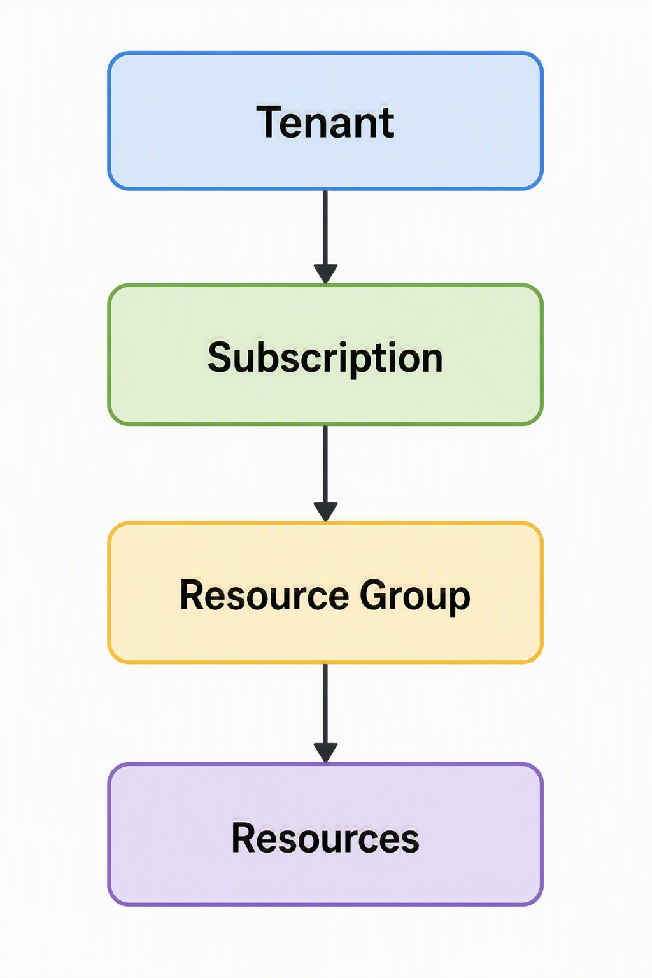

- Resource Groups & deployment basics

